Transfiguration Sunday
“Jesus Calling His First Disciples”
February 11, 2024

Call to Worship/Ringing of the Bells

Choir Selection
“My Best Friend is Jesus”

Hugs and Handshakes

Introduction to the Service

Pastor: Jesus' calling of his first disciples, as depicted in the Gospels, is a pivotal moment where He invites ordinary individuals, like fishermen, to follow Him and become "fishers of men." This act signifies the beginning of Jesus' public ministry and the formation of a community that would carry His teachings forward. For Lutherans, this event is crucial as it exemplifies the concept of vocation—God calling each person to serve in their unique capacities, a central theme in Lutheran theology. It also underscores the accessibility of God's call to all people, regardless of their background or occupation, highlighting the inclusive nature of Christ's message and mission.

Invocation

P: In the name of the Father and of the Son and of the Holy Spirit.
C: Amen.

Confession of Sins

P: If we say we have no sin, we deceive ourselves, and the truth is not in us.
C: But if we confess our sins, God, who is faithful and just, will forgive our sins and cleanse us from all unrighteousness.

Silence for reflection on God’s Word and for self-examination.

P: Let us then confess our sins to God our Father.
C: Most merciful God, we confess that we are by nature sinful and unclean. We have sinned against You in thought, word, and deed, by what we have done and by what we have left undone. We have not loved You with our whole heart; we have not loved our neighbors as ourselves. We justly deserve Your present and eternal punishment. For the sake of Your Son, Jesus Christ, have mercy on us. Forgive us, renew us, and lead us, so that we may delight in Your will and walk in Your ways to the glory of Your holy name. Amen.

Forgiveness of Sins

P: In the mercy of almighty God, Jesus Christ was given to die for us, and for His sake God forgives us all our sins. To those who believe in Jesus Christ He gives the power to become the children of God and bestows on them the Holy Spirit. May the Lord, who has begun this good work in us, bring it to completion in the day of our Lord Jesus Christ.
C: Amen.

873 Christ, Whose Glory Fills the Skies
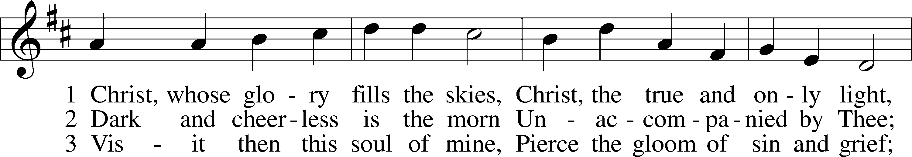
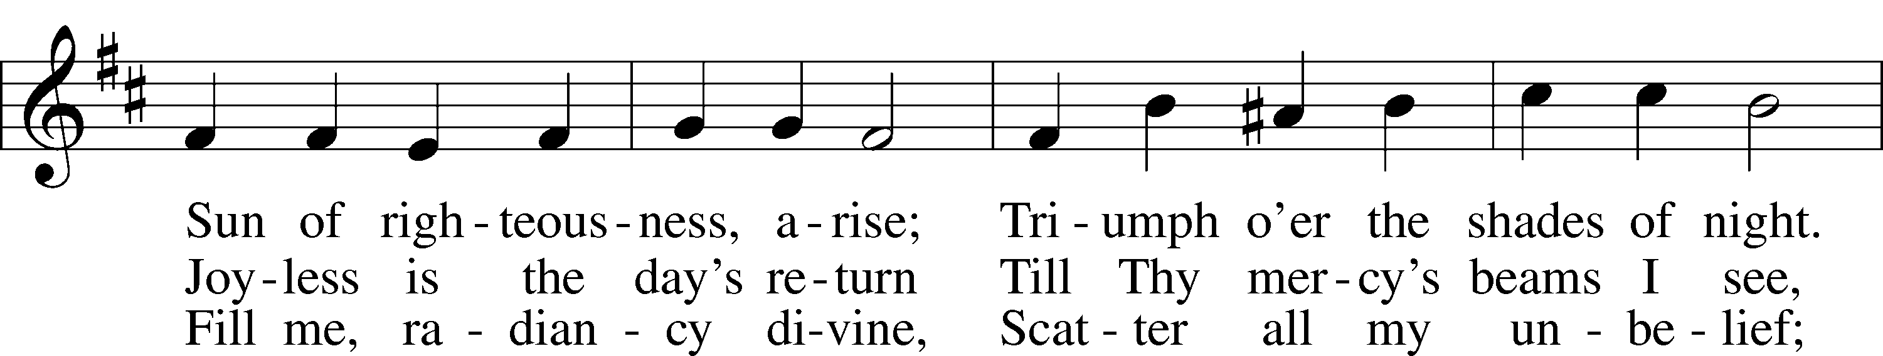
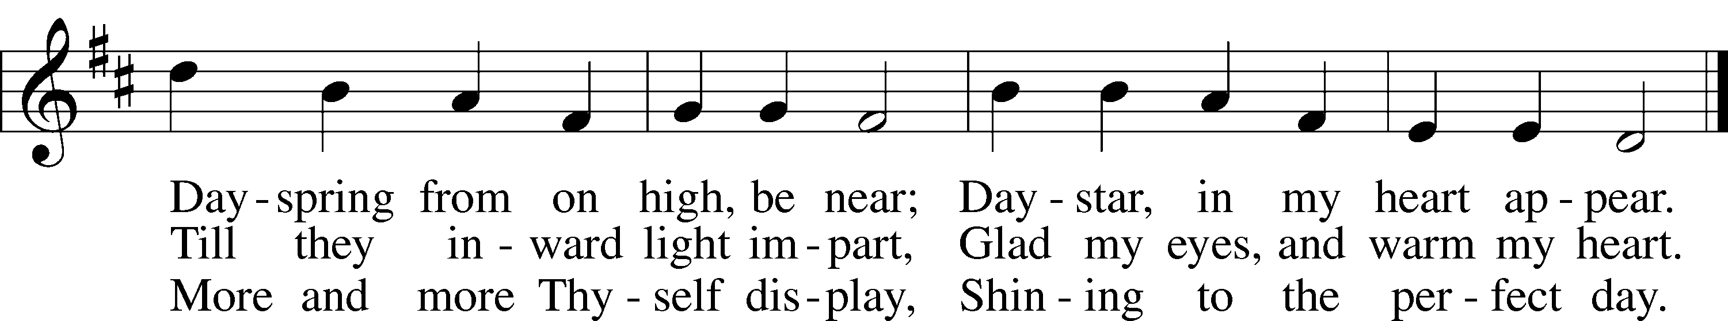
Text: Charles Wesley, 1707–88
Tune: attr. Johann G. Werner, 1777–1822
Text and tune: Public domain

The Introit: "The Dawn of Grace: Jesus Begins His Ministry"

Pastor: In Galilee's gentle embrace, a story unfolds,
Congregation: Where waters whisper tales of old.
Pastor: A carpenter, in humble guise,
Congregation: Steps forth under open skies.

Pastor: Not clad in gold, nor thrones to claim,
Congregation: But in His eyes, a holy flame.
Pastor: Jesus of Nazareth, the promised One,
Congregation: Begins His work, His mission begun.

Pastor: Three years of journeys lay ahead,
Congregation: Where His feet would tread, and His words would spread.
Pastor: A ministry not of sword or might,
Congregation: But of love, and truth, and heavenly light.

Pastor: He spoke in parables, stories sown,
Congregation: In hearts of men, His love was shown.
Pastor: The blind could see, the lame could walk,
Congregation: The mute would speak, and the crowds would flock.

Pastor: Beside the sea, upon the mount,
Congregation: His words would flow, like a living fount.
Pastor: “Blessed are the meek,” He gently said,
Congregation: A crown of kindness on His head.

Pastor: He dined with sinners, touched the unclean,
Congregation: In Him, God's face was truly seen.
Pastor: A message of grace, so freely given,
Congregation: A path to God, a bridge to heaven.

Pastor: He calmed the storms, both sea and soul,
Congregation: With a whisper, all was whole.
Pastor: Miracles were His tender sign,
Congregation: Of a love divine, a design benign.

Pastor: Yet not all hearts were swayed to hear,
Congregation: In whispered corners, grew doubt and fear.
Pastor: “Who is this man?” they questioned still,
Congregation: Unaware of His Father's will.

Pastor: For Jesus knew the road He'd tread,
Congregation: A path of sorrows, for us He led.
Pastor: To cross, to tomb, to glorious rise,
Congregation: His journey marked under open skies.

Pastor: So let us remember those years of grace,
Congregation: When Jesus walked in our earthly space.
Pastor: His ministry, a beacon light,
Congregation: Guiding us through the darkest night.

Pastor: In Galilee's embrace, it all began,
Congregation: The story of God's love for man.
Pastor: A carpenter, with holy flame,
Congregation: Jesus, the Savior, that's His name.

Gloria in Excelsis LSB 154

P: Glory to God in the highest, and peace to His people on earth.
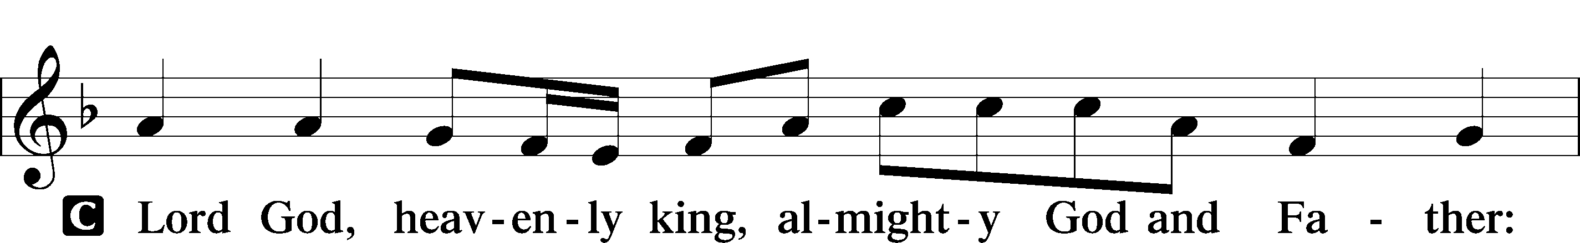
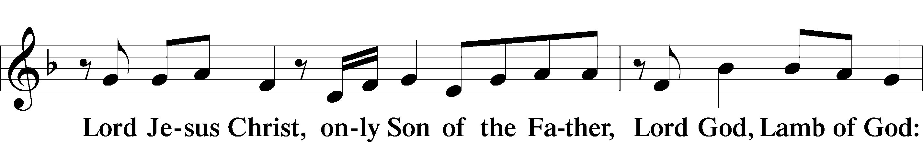
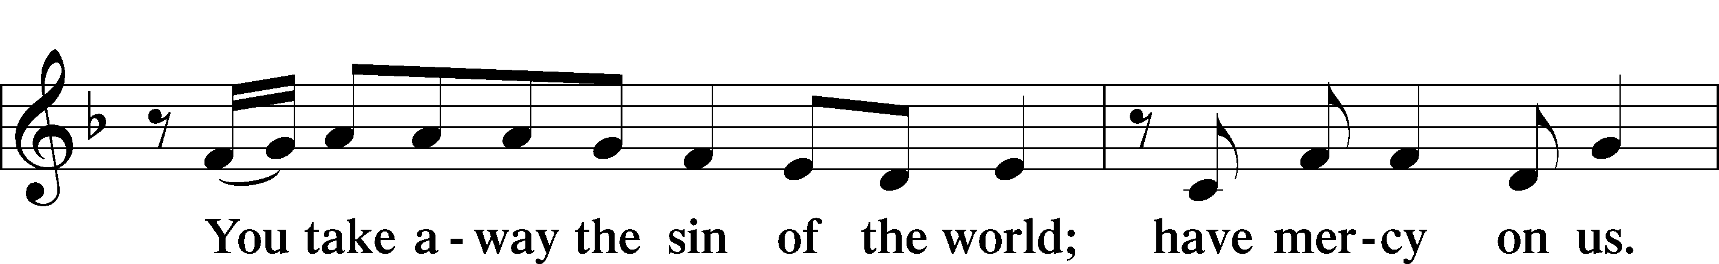
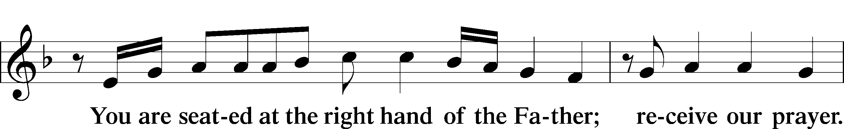
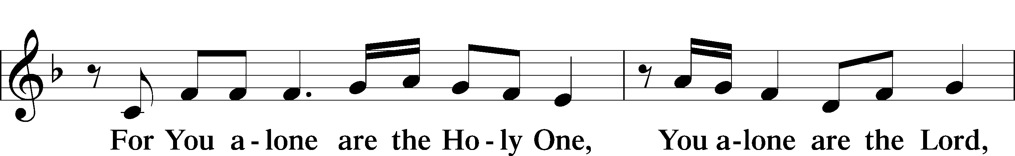
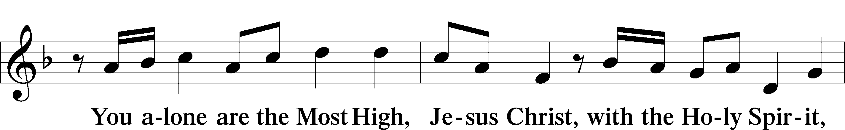
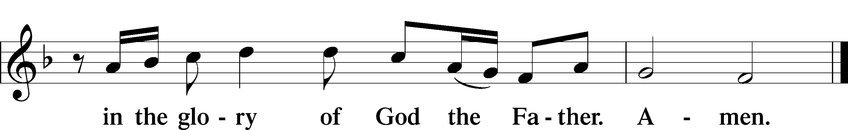

The Opening Collect Prayer

Pastor: Almighty and Everlasting God, who called Your beloved Son Jesus Christ to begin His earthly ministry among us, grant us the grace to follow His example of humble service and steadfast love. As He walked in obedience to Your will, proclaiming the Good News, healing the sick, and bringing hope to the downtrodden, so may we be inspired to live out our faith with boldness and compassion. Strengthen us by Your Spirit, that in all we do, we may manifest the love of Christ, who lives and reigns with You and the Holy Spirit, one God, now and forever.
Congregation: Amen.

Reader: This passage from Isaiah speaks of a servant chosen by God to restore Israel and bring light to the nations. The theme of being called from the womb emphasizes God's providential plan, similar to how Jesus' ministry was part of a divine mission.

Old Testament Reading Isaiah 49:1–6

1Listen to me, O coastlands, and give attention, you peoples from afar.
The Lord called me from the womb, from the body of my mother he named my name.
2He made my mouth like a sharp sword; in the shadow of his hand he hid me;
he made me a polished arrow; in his quiver he hid me away.
3And he said to me, “You are my servant, Israel, in whom I will be glorified.”
4But I said, “I have labored in vain; I have spent my strength for nothing and vanity;
yet surely my right is with the Lord, and my recompense with my God.”
5And now the Lord says, he who formed me from the womb to be his servant,
to bring Jacob back to him; and that Israel might be gathered to him—
for I am honored in the eyes of the Lord, and my God has become my strength—
6he says: “It is too light a thing that you should be my servant to raise up the tribes of Jacob and to bring back the preserved of Israel; I will make you as a light for the nations, that my salvation may reach to the end of the earth.”

Reader: This is the Word of the Lord.
Congregation: Thanks be to God.

Gradual Psalm 23

Reader: The Lord is my shepherd; I shall not want, He makes me lie down in green pastures.
Congregation: He leads me beside still waters, restoring my soul, guiding me in paths of righteousness for His name’s sake.

Reader: Even though I walk through the valley of the shadow of death, I will fear no evil, for You are with me.
Congregation: Your rod and Your staff, they comfort me; You prepare a table before me in the presence of my enemies.

Reader: Here, Paul addresses the church in Corinth, emphasizing the call to be saints together with all those who call upon the name of Jesus. This passage connects with the theme of calling by highlighting how believers, like the disciples, are called into fellowship with Jesus Christ.

Epistle 1 Corinthians 1:1–9

1Paul, called by the will of God to be an apostle of Christ Jesus, and our brother Sosthenes,
2To the church of God that is in Corinth, to those sanctified in Christ Jesus, called to be saints together with all those who in every place call upon the name of our Lord Jesus Christ, both their Lord and ours:
3Grace to you and peace from God our Father and the Lord Jesus Christ.
4I give thanks to my God always for you because of the grace of God that was given you in Christ Jesus, 5that in every way you were enriched in him in all speech and all knowledge—6even as the testimony about Christ was confirmed among you—7so that you are not lacking in any spiritual gift, as you wait for the revealing of our Lord Jesus Christ, 8who will sustain you to the end, guiltless in the day of our Lord Jesus Christ. 9God is faithful, by whom you were called into the fellowship of his Son, Jesus Christ our Lord.

Reader: This is the Word of the Lord.
Congregation: Thanks be to God.

Alleluia and Verse LSB 156

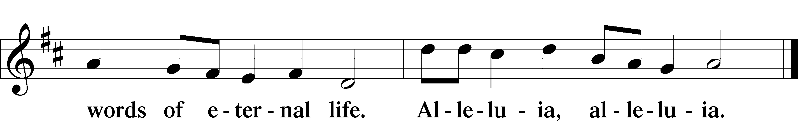

Pastor: This passage describes the beginning of Jesus' ministry and the calling of His first disciples, Simon, Andrew, James, and John. Jesus' proclamation, "The time is fulfilled, and the kingdom of God is at hand; repent and believe in the gospel," sets the stage for His ministry. The immediate response of the disciples to Jesus' call illustrates the compelling nature of His presence and message.

Holy Gospel Mark 1:14–20

Pastor: The Holy Gospel according to St. Mark, the first chapter.
Congregation: Glory to You, O Lord.

14After John was arrested, Jesus came into Galilee, proclaiming the gospel of God, 15and saying, “The time is fulfilled, and the kingdom of God is at hand; repent and believe in the gospel.”
16Passing alongside the Sea of Galilee, he saw Simon and Andrew the brother of Simon casting a net into the sea, for they were fishermen. 17And Jesus said to them, “Follow me, and I will make you become fishers of men.” 18And immediately they left their nets and followed him. 19And going on a little farther, he saw James the son of Zebedee and John his brother, who were in their boat mending the nets. 20And immediately he called them, and they left their father Zebedee in the boat with the hired servants and followed him.

Pastor: This is the Gospel of the Lord.
Congregation: Praise to You, O Christ.

688 “Come, Follow Me,” the Savior Spake sts. 1–3, 5

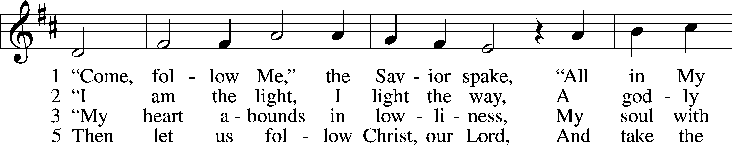
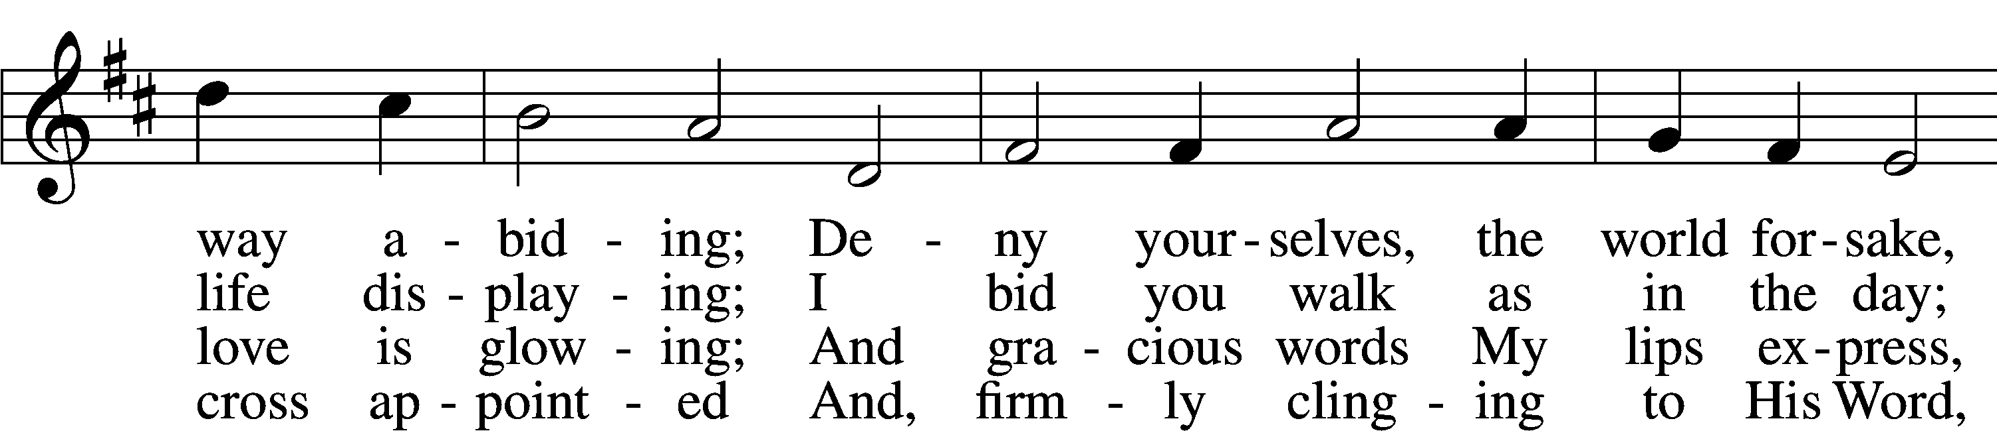
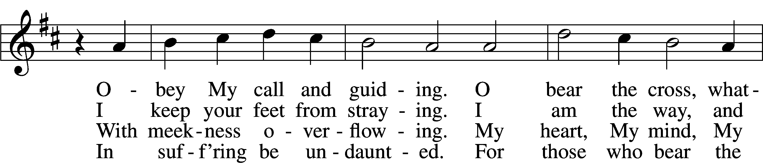
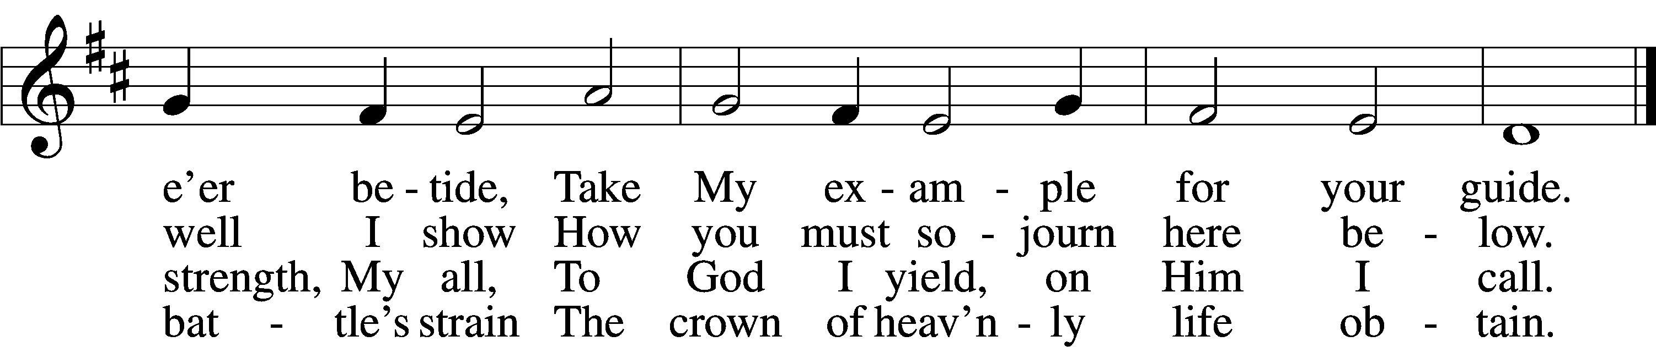
Text: Johann Scheffler, 1624–77; tr. Charles W. Schaeffer, 1813–96 Tune: Bartholomäus Gesius, c. 1555–1613, adapt. Text and tune: Public domain

The Children's Message (by Sonja Kirchoff)

AGPS # 170 "Lord of the Dance" Stanzas 1-4 (music on Insert)

- I danced in the morning when the world was begun,
and I danced in the moon and the stars and the sun,
and I came down from heaven and I danced on the earth.
At Bethlehem I had my birth.

Refrain: Dance, then wherever you may be;
I am the Lord of the Dance, said He.
And I’ll lead you all wherever you may be,
and I’ll lead you all in the dance, said HE.

- I danced for the scribe and the Pharisee,
see but they would not dance and they would not follow me.
I danced for the fishermen, and for James and John;
they came to me and on the dance went on. Refrain.

- Danced on the sabbath when I cured the lame,
the holy people said it was a shame;
they whipped and they stripped and they hung Me high;
and they left Me there on a cross to die. Refrain.

- I danced on a Friday and the sky turned black;
it’s hard to dance with the devil on your back;
they buried my body and they thought I’d gone,
but I am the dance and I will go on. Refrain.

Sermon - "Jesus Begins His Earthly Ministry"

Apostles’ Creed

C: I believe in God, the Father Almighty,
maker of heaven and earth.
And in Jesus Christ, His only Son, our Lord,
who was conceived by the Holy Spirit,
born of the virgin Mary, suffered under Pontius Pilate,
was crucified, died and was buried.
He descended into hell.
The third day He rose again from the dead.
He ascended into heaven
and sits at the right hand of God the Father Almighty.
From thence He will come to judge the living and the dead.
I believe in the Holy Spirit,
the holy Christian Church,
the communion of saints,
the forgiveness of sins,
the resurrection of the body,
and the life everlasting. Amen.

Offering

Offertory - AGPS #170 - "Lord of the Dance", Stanza 5 (Music on Insert)

- They cut me down and I leapt up high,
I am the life that’ll never, never die;
I’ll live in you if you’ll live in Me;
I am the Lord of the Dance, said He.

Refrain: Dance, then wherever you may be;
I am the Lord of the Dance, said He.
And I’ll lead you all wherever you may be,
and I’ll lead you all in the dance, said HE.

Congregational Prayers

Pastor: Heavenly Father, in reverence and awe, we come before You, recalling the humble beginnings of Jesus' earthly ministry.
Congregation: As He stepped into the world He created, let us reflect on the profound humility and boundless love that guided His every action.

Pastor: Lord Jesus, as You were baptized by John in the Jordan, You showed us the way of righteousness and obedience.
Congregation: Help us to follow Your example, submitting our lives to the Father's will, seeking to please Him in all we do.

Pastor: Holy Spirit, who descended upon Jesus like a dove, fill our hearts with Your presence.
Congregation: May Your guidance and wisdom lead us in paths of truth and grace, empowering us to be Your faithful witnesses in the world.

Pastor: Father, as Jesus called His first disciples, He invites us, too, to be fishers of men.
Congregation: Give us the courage to respond to His call, to leave behind what hinders us, and to follow Him wholeheartedly.

Pastor: We thank You for the teachings, miracles, and the perfect example of love and service that Jesus demonstrated during His ministry.
Congregation: May we learn from His words and actions, growing in love for You and for our neighbors.

Pastor: In the quiet of our hearts, we also present our personal intentions and the needs of our community.
Congregation: Lord, guide us in our journey of faith. May we walk in the footsteps of Jesus, sharing His love, spreading His Gospel, and shining His light in every corner of our lives.
Pastor: In Jesus' name, we pray,
Congregation: Amen.

Lord’s Prayer

P: Lord, remember us in your kingdom and teach us to pray:

C: Our Father who art in heaven,
hallowed be Thy name,
Thy kingdom come,
Thy will be done on earth as it is in heaven;
give us this day our daily bread;
and forgive us our trespasses
as we forgive those who trespass against us;
and lead us not into temptation,
but deliver us from evil.
For Thine is the kingdom and the power
and the glory forever and ever. Amen.

The Closing Blessing

Pastor: May the grace of the Lord Jesus Christ, who calls us to be His disciples, empower and guide you. May the love of God the Father, who created you for His purpose, sustain and uphold you. And may the fellowship of the Holy Spirit, who equips and sends us out, inspire and lead you in all your ways. Go forth in peace, as ambassadors of Christ's love and light in the world.
Congregation: Amen.

Announcements

537 Beautiful Savior
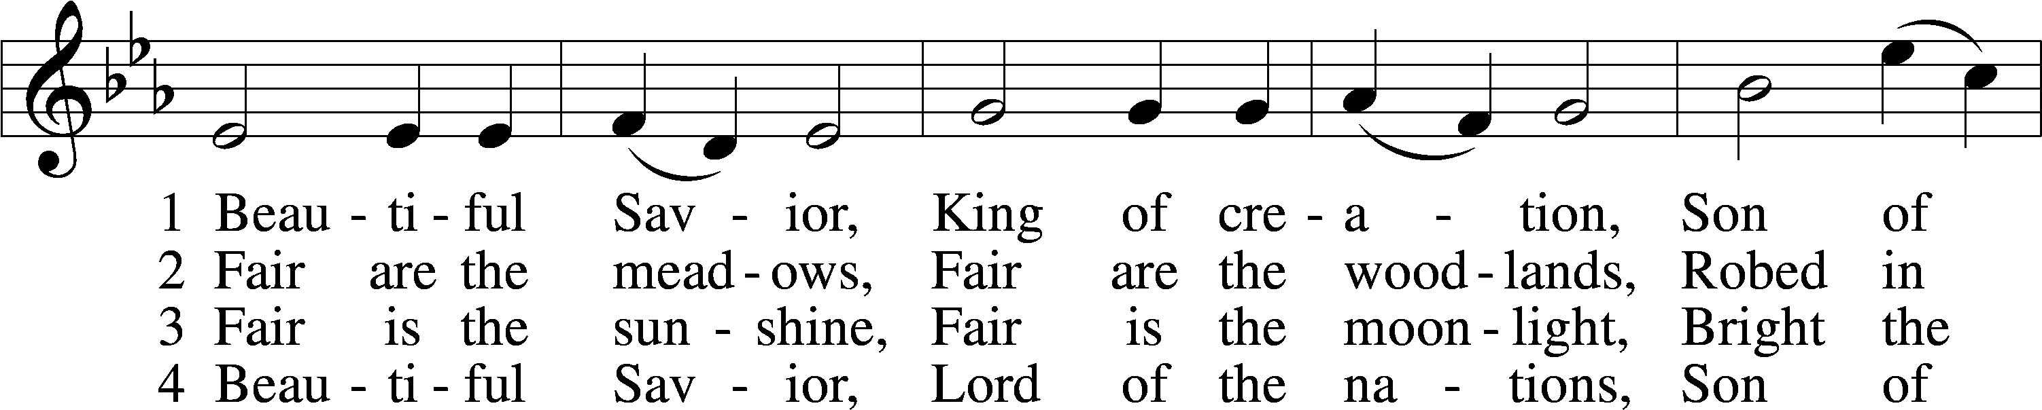
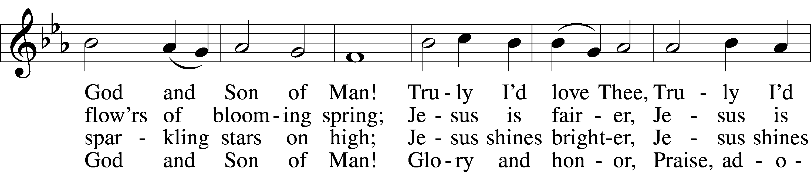
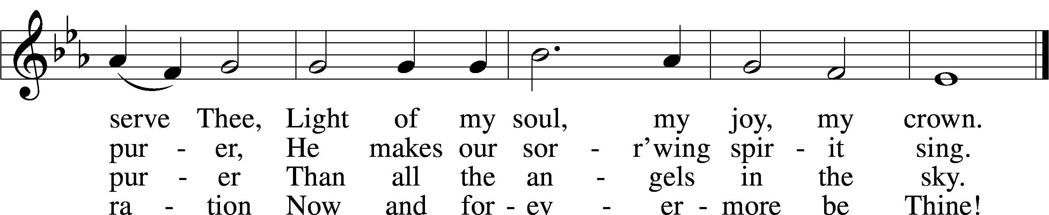
Text: Münsterisch Gesangbuch, 1677, Münster; tr. Joseph A. Seiss, 1823–1904
Tune: Silesian, 19th cent.
Text and tune: Public domain

Acknowledgments
Divine Service, Setting One from Lutheran Service Book
Unless otherwise indicated, Scripture quotations are from the ESV® Bible (The Holy Bible, English Standard Version®), copyright © 2001 by Crossway, a publishing ministry of Good News Publishers. Used by permission. All rights reserved.
Created by Lutheran Service Builder © 2024 Concordia Publishing House.

